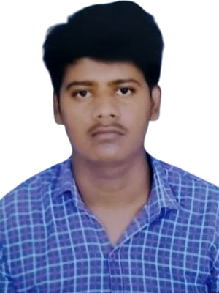
Title:Explainable Artificial Intelligence for Interpreting Machine Learning Models Name: Raviraj and Sachin kumar
University/Organization: Delhi Technological University, Delhi,

Photograph

Organization Logo
Delhi Technological University, Delhi,

Abstract:
Machine Learning algorithms have been rapidly adopted across the breadth of medicine in recent years enabling state-of-the-art performance in both decision support and diagnostics. While state-of-the-art, most ML models have become black-boxes, which leads to the clinician becoming distrustful of the ML output as the models are not explainable. Medicine demands transparency and explainability for clinical decisions, and such medical decisions are made within the context of a medical system that demands adherence to protocol. In response, a comprehensible ML model utilizing a Random Forest classifier, a model for binary classification aided by post-hoc explanation methods, was constructed. Both binary classification using real medical data was tested and visually interpreted using Shapley Additive Explanations (SHAP) for feature importance and Local Interpretable Model-agnostic Explanations (LIME) for single prediction explanations. Results indicated state-of-the-art prediction accuracy at 0.964 with an F1 score at 0.963 while providing a visual indication of what the ML model had decided upon. As such, we may conclude that using ensemble models alongside post-hoc explanations enables a state-of-the-art trade-off between prediction and explainability in the domain of medicine.
Biography: Raviraj is currently pursuing the M.Tech degree in Data Science from Delhi Technological University, Delhi, India. His research interests include AI, retrieval-augmented generation (RAG), machine learning, data science, LLM, SWE and XAI.
Sachin kumar is pursing M.Tech in Data Science at Delhi Technological University , Delhi . His interests lie in the fields of ML, DL GenAI, XAI and AI in healthcare.

